Game Design Document
Tutorial 7 Assessed Question
Woodwork

High Level Description
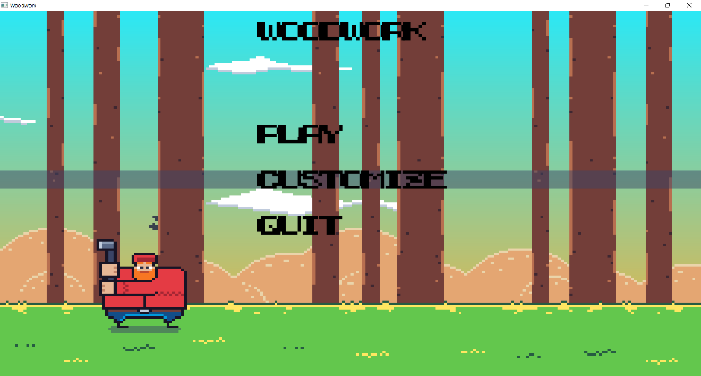
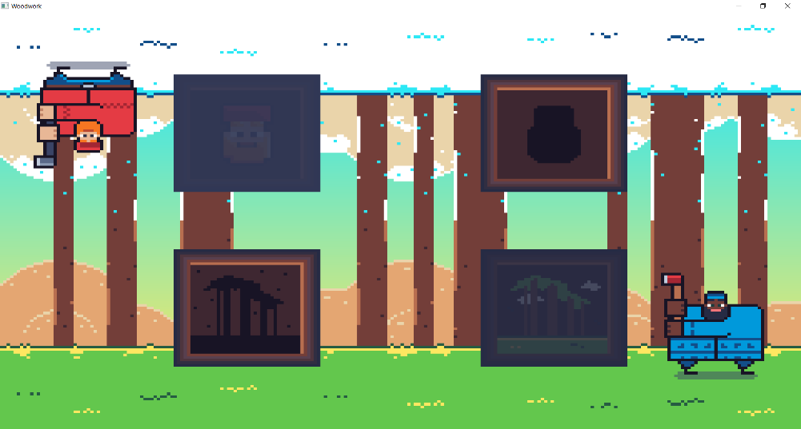
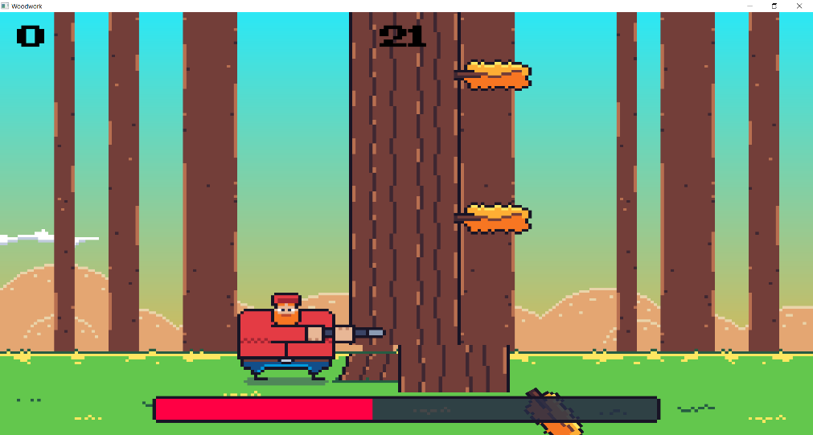
Woodwork is a colourful, fun, rewarding game that allows a player to enter a world where you play as a lumberjack, the game repeats and you build up score the further you can chop wood.

In this game you can unlock and change the character and the map as you build up skill and knowledge of how the game works.

The game uses simple pixel art graphics with neutral colours to appeal to both gender audiences.

The sounds of the game are all 8 bit sounds to match the theme of the pixel art and give the game a more vintage experience, as if you was playing on an arcade back in the 1980s.

Character and Story
This game is not story driven, instead its more of a repeat game where the story is up to the players imagination.
- Tree Logs – Both styled differently for winter and summer map, player must chop each log chunk down, once they have been hit, they have sound of them falling out of the tree.

- Characters – Both styled differently for winter and summer, player may choose and shows unique items like clothes and axe.
- Maps – Both styled differently for winter and summer, player can choose and shows unique animations like the bird in the summer, they both have their unique music too.

Theme and Setting
The characters are fun, the controls of the game make them very reactive and there is minimal text so you can jump in and play at any age, the score on the top of the screen so it allows the player to identify their score and could also pressure them to getting a higher score, increasing the games difficulty. There is no gender specific audience, therefore the game’s colours are simple like green, blue, yellow, white, depending on the map and character you choose. The game can be played in a winter or summer setting, both of which are unique environments for the player to enjoy.

3.1 Story Progression
There is no story to be told in this game, the objective is to build a high score, and each playthrough the player may build a higher score then last time, once the player dies it shows them a gravestone in the place the player was in, and a sound will play too, showing the score at the top and the high score at the top left.
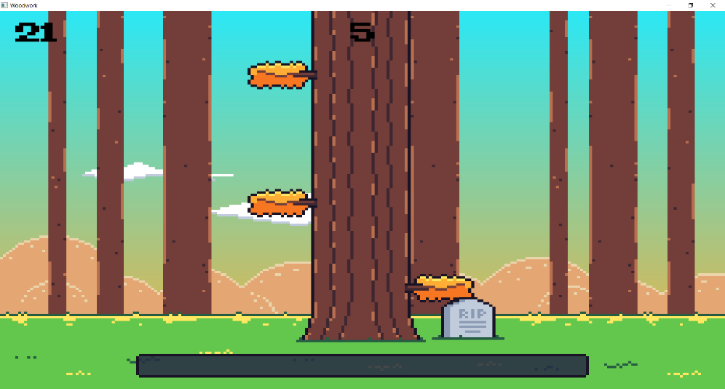

Gameplay

4.1 Goal
The game starts with a score of 0, each log the player cuts from the tree will send the score up by 1 point. The goal of the game is to get a high score; however, smaller goals are things like unlocking the character at 150 points and unlocking a new map at 250 points.
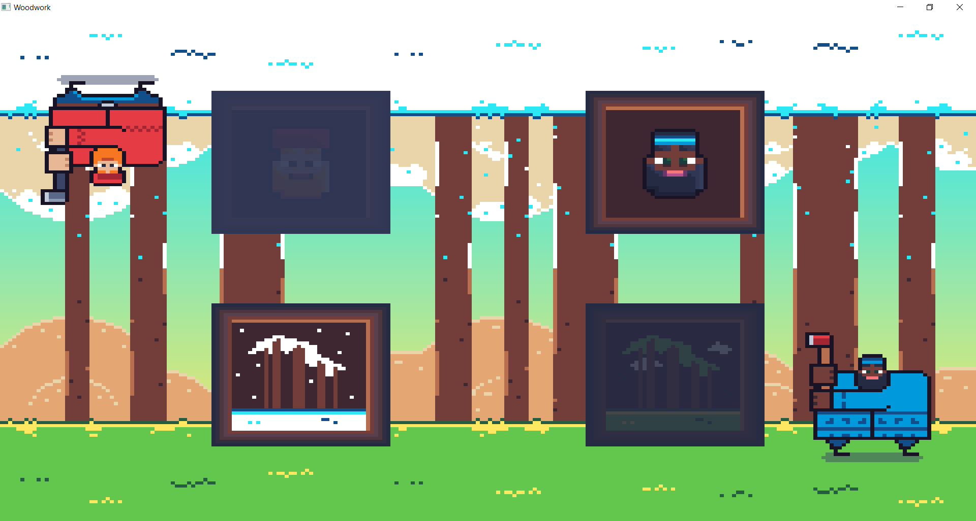

4.2 Player Skill
There is a tutorial menu state that allows players to learn the core mechanics of the game. Once the player advances to the main game loop, the game’s difficulty is based of the time bar at the bottom of the screen, the player has a finite amount of time to advance and gain more time, the first map is 50% easier than the second map, in which they can try and reach a new high score. Additionally, the player skill will jump once they go onto the second map as that’s where the difficulty is bumped up.

4.3 Items
The items in this game are limited to just branches, every time a branch hits the player it causes the player to die and when this happens the game will end, and the game will display the high score.

4.4 Progress
This is a time-based game where each second the difficulty ramps up, not noticeable second to second however if you jumped in after five minutes there would be a difference in the change of pace, also, once the player reaches the score of 150, the player map unlock a new character, once the player reaches a score of 250, they unlock the harder map, and as mentioned before the difficulty rises the same just with an additional boost to make the game harder then it was on the first map.

4.5 Losing
If you hit a branch, player will die, and the game will end, or if the time runs out, player will die, this causes the player sprite to be replaced with a gravestone, and then the high score will pop up with the name of the player who managed it.
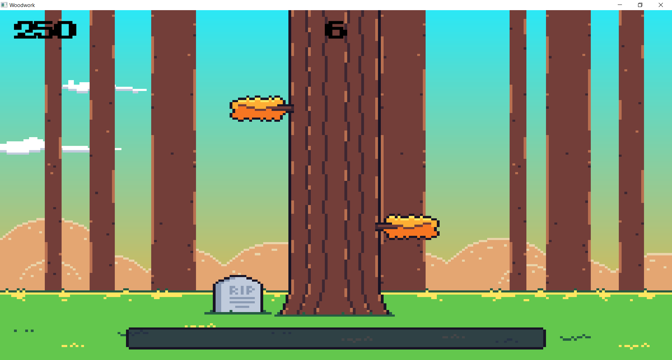

4.6 Controls
Input. | What it should do.
MENU + CUSTOM | MENU + CUSTOM
Up arrow or W key. | Makes the selection change upwards.
Down arrow or S key. | Makes the selection change downwards.
Enter key. | Enters a new game state based of the selection’s position. Or if in customization with select a new character or menu and change the game’s look.
(CUS) Right arrow or D key. | Makes the selection change right.
(CUS) Left arrow or A key. | Makes the selection change left.
(CUS) Escape key. | Backs the game state to menu state.
GAME | GAME
Right arrow or D key. | Move character to the right.
Left arrow or A key. | Move character to the left.
Enter key. | Hits the tree.
S key. | Save the current game’s progress.
R key. | Restart the game.
Q key. | Resumes / pauses the game.

Gameplay
Logs – The player will chop these down, as each log falls the time bar gains an extra bit of time depending on the map.
Time - The player has a finite amount of time to cut logs down, if the player fails to cut a log down before the time is up the player will die ending the run.
Branches – Player must avoid the branches to stay alive, if the player hits the branch the game will kill the player making an end to the run.
End – No end it is just a repetitive loop.

Difficulty
Becomes harder on the second map, as the player progresses the player has less time to react to the branches and choose which side to stick to, and with the logs being cut faster, the player has to react to where the branches are to avoid being hit and killed, to enable the difficulty, here are a few things we can tweak.
- Game speed.
- Gap random generator.

Art Style
Bright, fun and playful background, all pixel art, all rounded bright environment, makes the user feel free, however it has a fun cartoony style to it so it would be simple to design, the colours will be bright and contrast to summer and there will be a foreground of grass which covers the screen, midground where the player can see the character and tree behind and background, there will also be birds and clouds that add life to the background, across the screen which will keep scrolling forever on a repetitive loop.
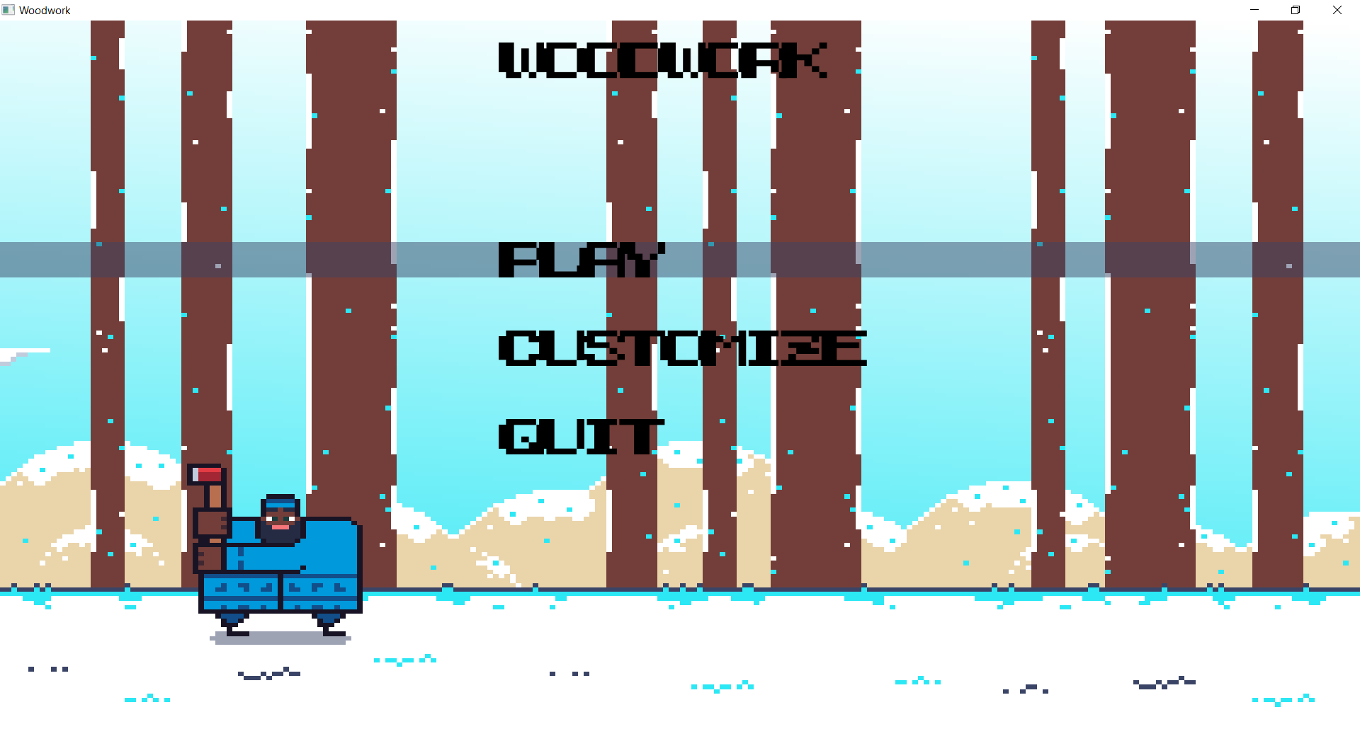
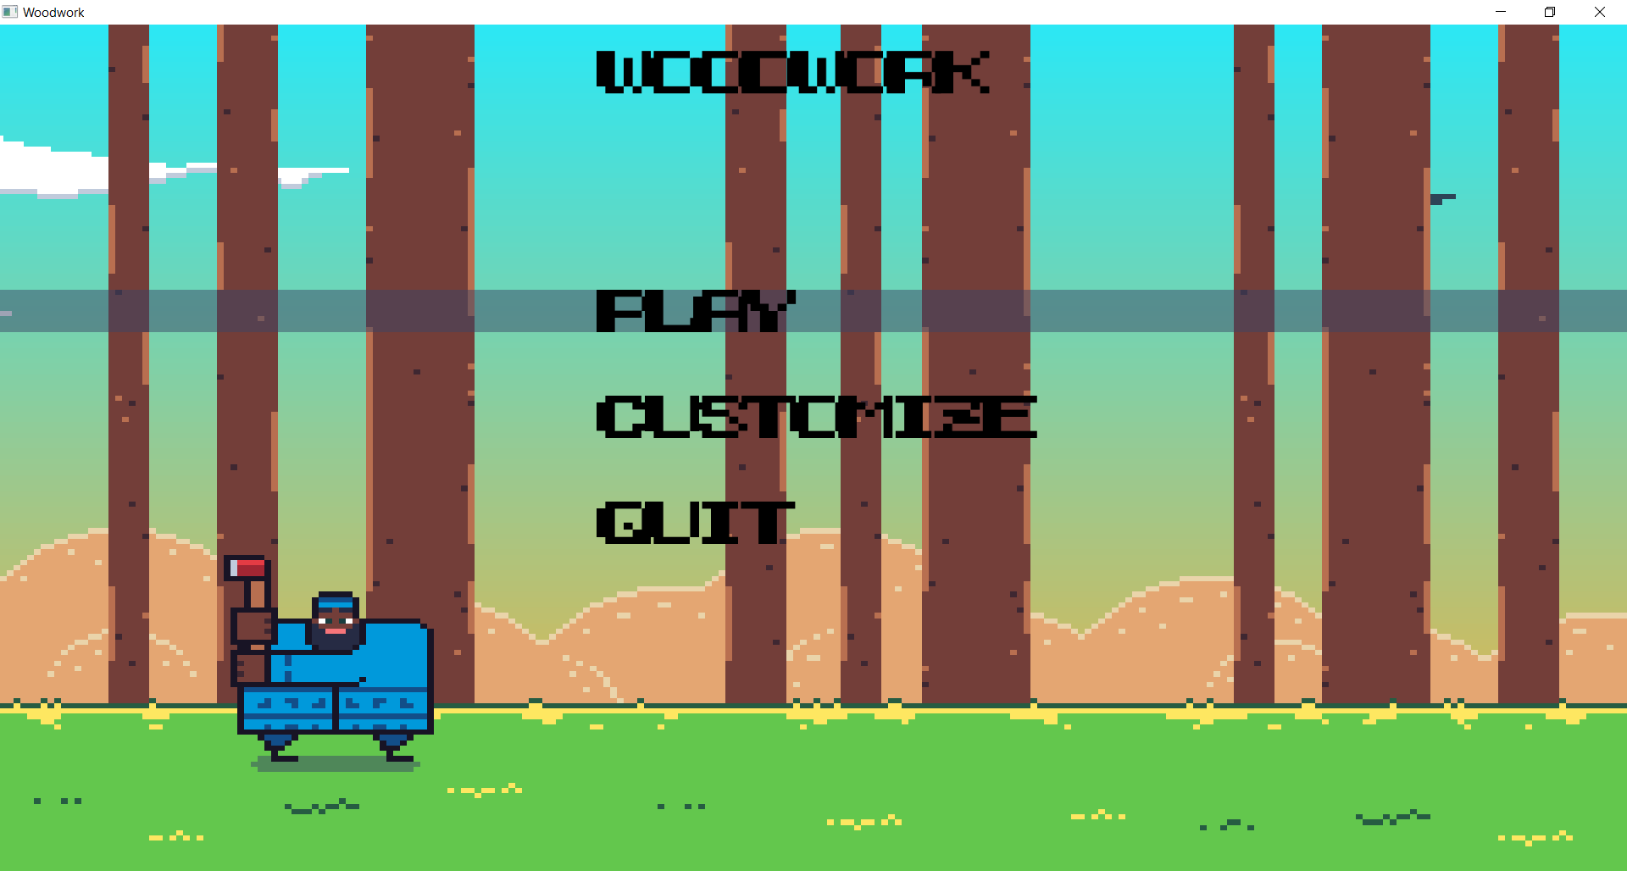

Music and Style
This would be a calm uplifting fun lo-fi music, calming to the listener as they journey throughout the game, which should have distinctive synths which make the user feel like they are playing a retro game. An example track is shown below.

Demographics, Platform, and Marketing
This game will specifically be designed for a low power arcade board with limited memory, limited sprite support, limited colour palette with only 32-bit registers. Meaning it would have to be made simplistically.
This game will be aimed at all genders, it will have a broad appeal, no gore, or adult themes so that all ages can play, quite abstract setting and cartoon like.
People will be attracted by the simple yet charming music and sound effects, the graphics will carry a heavy weight to take advantage of the music and dystopia setting to make a unique impression amongst a wide range of other arcade games, players will keep playing to aim for a higher place on the leader board and therefore spend a lot of money to get better at the game.

Monetization
As mentioned, previous players will compete across Lan networks or online in esports competitions to encourage people to compete for a high score with prizes provided to encourage players to compete. The game is designed to be short and addictive, so players keep spending more money to get better at the game.

Game Decomposition

Menu State

If Start = True
If Quit = True

Game State
Paused State
If Paused = True Or If Game Ended = True
If Restart = True

